Brieanna Williams
CSD325
9.2 Assignment
API Learning Tutorial
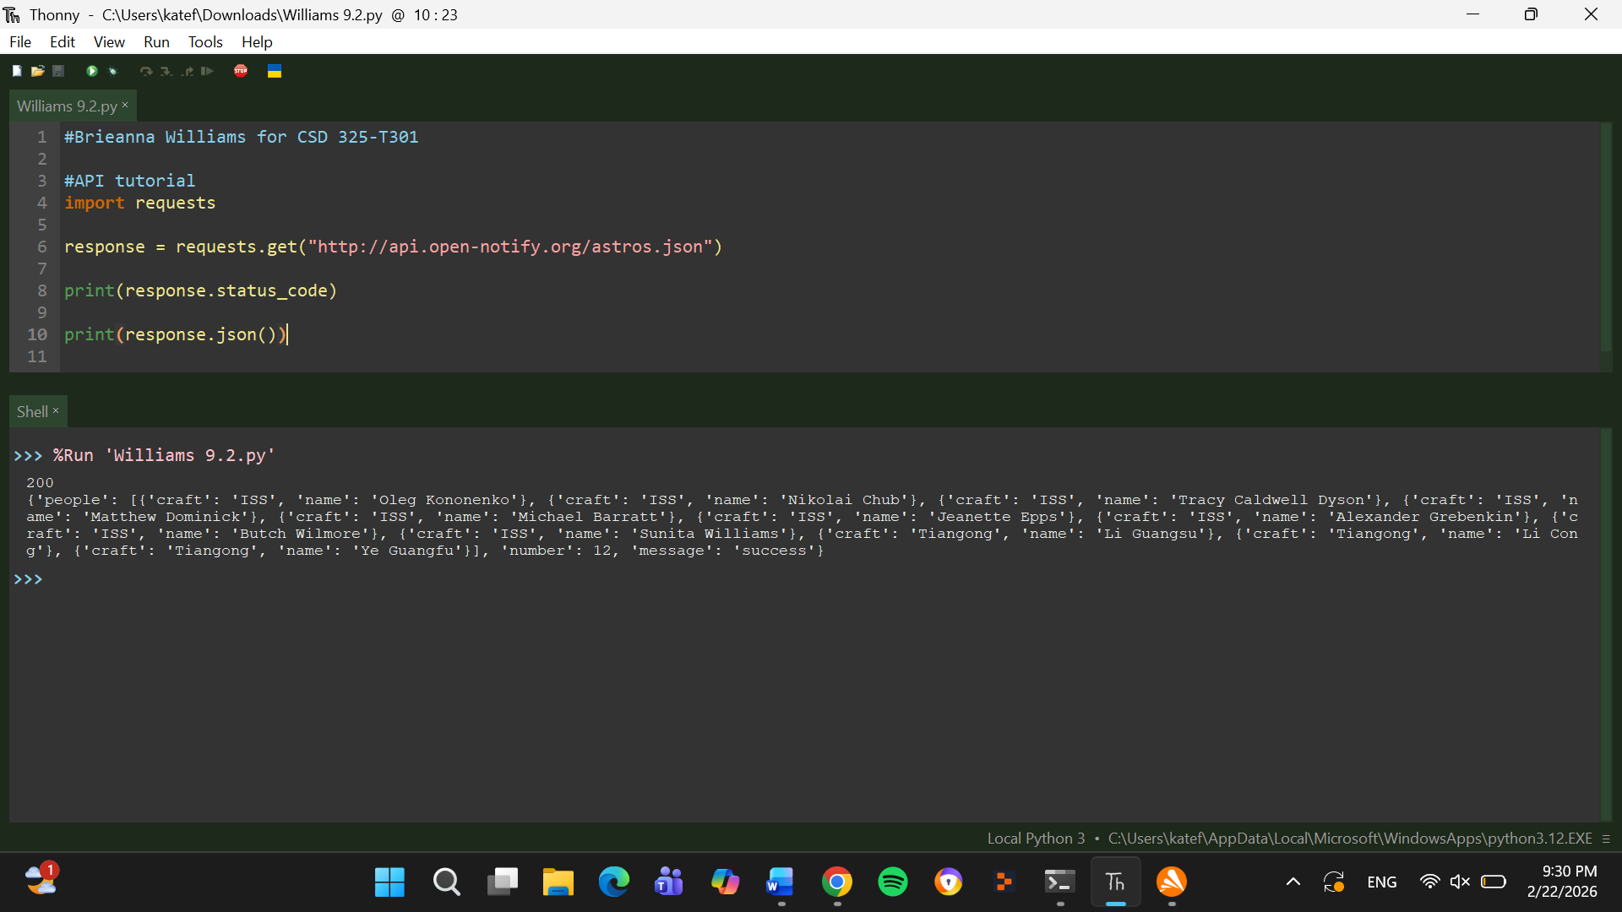
My Code
